Who can use this API
Software developers or vendors supplying Providers with software that supports their operational needs. This software must meet all API testing and conformance assessment requirements stipulated within the Developer Portal before it will be authorised to operate against the Production API. Under certain circumstances, software may need to reaffirm its conformance and API testing status, such as:
- A significant update to the existing API (as APIs are enhanced and improved over time)
- Your software undergoes a material change
Please see the Conformance and API Testing sections for more information.

How to use this API
Developers intending to use this API should understand the intent of its endpoints and the role their prospective software (shown in red) would play in this context. This is best surmised via the below visual.
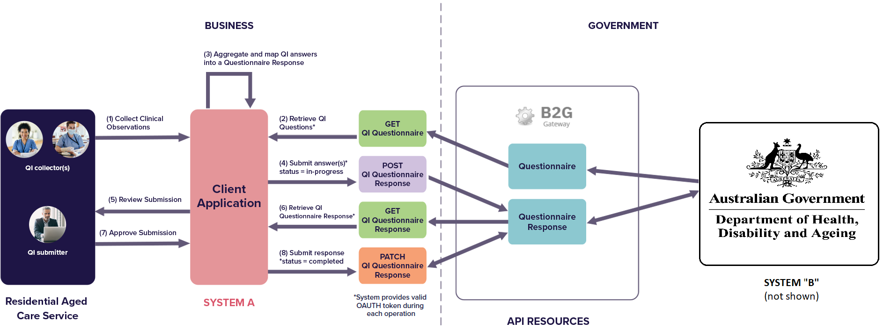
The most common use-case for the B2G API will be to facilitate the system-to-system interchange of quality indicator data. In the above example, System "A" represents a Clinical Management System (CMS) (or equivalent) that has been developed on the Business-side and System "B" represents the Government repository where quality indicator data is stored for processing to support, in this case, the QI Program outcomes in accordance with the Aged Care Act 1997.
A standard sequence for this data interchange might look like this:
Step (1): Aged Care employees collect regular clinical observations about Care Recipients in their Service over the course of the quarter as part of routine care. These observations might be collected directly into "System A" (pictured above) by the staff, uploaded into "System A" from a paper-based record or loaded from an otherwise separate system or systems. Regardless of the method(s) of acquiring and storing the data, a definable "System A" (which could be made up of separate sub-systems or products) will need to be responsible for managing the submission of the data in an auditable and conformant way.
Step (2): System "A" will retrieve a current version of the QI Questionnaire on behalf of the given Provider and Program Payment Entity. This step may not be necessary if the current Questionnaire structure is hard-coded into System "A".
Step (3): At the end of the data collection period, the data collected by System "A" can be aggregated and mapped into a QI QuestionnaireResponse structured payload.
Step (4): The formality of the submission approval process is at the discretion of the business. In the figure above, step 4 demonstrates a workflow where an initial POST of the QuestionnaireResponse payload to the B2G gateway is made with a status of "in-progress". This allows for corrections and amendments to be made with a PATCH call (not-pictured) while giving System "A" visibility of any validation errors or warnings that are found in the data.
Step (5): Assuming a successful POST in step (4) with no validation errors, it is time to formally "submit" the QI QuestionnaireResponse. In this figure the submission is first presented to the user authorised by System "A" to author and approve the submission to the Government.
Step (6): In order to accurately present to the authorised submitter what data has been transmitted to the Government, the System "A" elects to do a GET operation against the QuestionnaireResponse.
Step (7): The authorised user will review, potentially alter, and approve/submit the QI submission. All applicable data validations must be treated and the submission finalised prior to the due date.
Step (8): System "A" then submits a PATCH QI QuestionnaireResponse operation to reflect the change in status from "in-progress" to "completed". At this point, assuming a successful response (no errors have been returned) from the B2G Gateway, the answers enclosed in the QuestionnaireResponse have successfully be transmitted to System "B" and propagated to the relevant downstream processes. If a response has been formally submitted, no further action is required unless advised otherwise by the Government for the given reporting period.
As part of the submission, the Provider's Program Payment Entity must be designated as the "subject" of the QuestionnaireResponse. In order to make a Reference to the "HealthcareService", a unique and persistent URI must be provided that resolves to the Provider's Program Payment Entity. To facilitate discovery of this URI, the Organization and HealthcareService endpoints are available in the Provider Management API. This allows a user/application on the business-side to transverse the Provider/Program Payment Entity hierarchy to discover the HealthcareService's unique ID as follows (note: URIs are illustrative only));
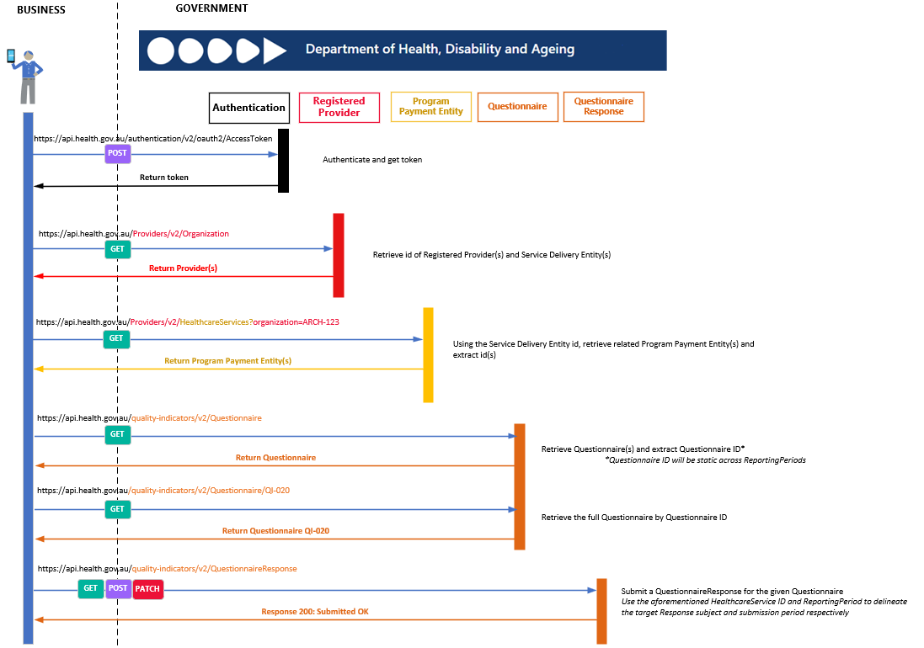
Note that when performing a formal “submit” by setting the QuestionnaireResponse status to “completed” or “amended”, additional information is required to be included in the B2G API call. This additional information is to provide at least one (1) of the following two (2) header fields in the API call to identify the user performing the action on behalf of the Provider. This information is then used to ensure that the identified GPMS user has one of the “QI Role Org” or “QI Role (Service)” roles assigned to them to validate that they are authorised to perform a formal submission on behalf of the Provider,
API Header Field | Description
X-Federated-Id | This is the Digital ID (email address) of the GPMS user in RAM
X-User-Email | This is the email address of the GPMS user when their GPMS account was created

